Playwright Testing for SHOPPERS STOP

Folder Structure:

Command to initiate the playwright setup

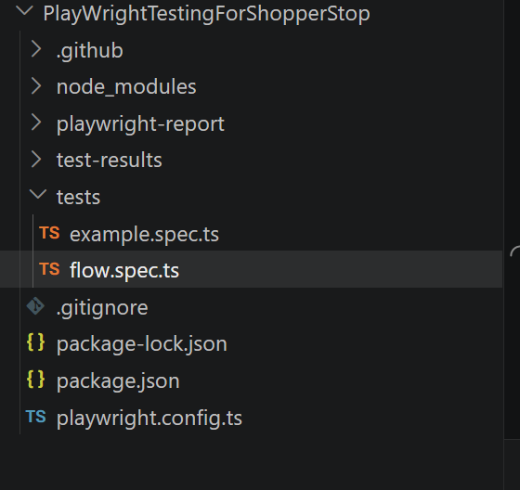

What is given to test:
- Open home page
- Verify title or banner to be visible
- Use the search bar to search for a keyword
- Verify search result page related content appears

Test case: postive
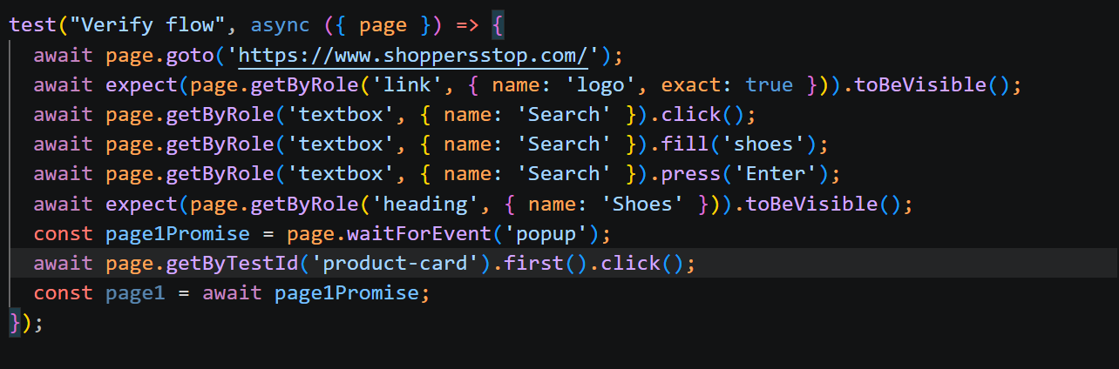

Commad to test: npx playwright test
For verify flow
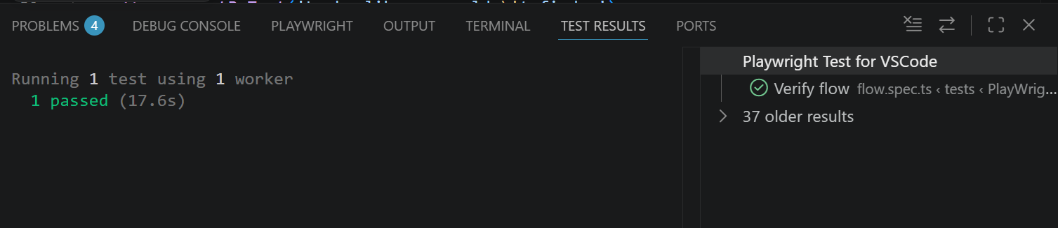

Negative: when we don’t have a product it should show product not found
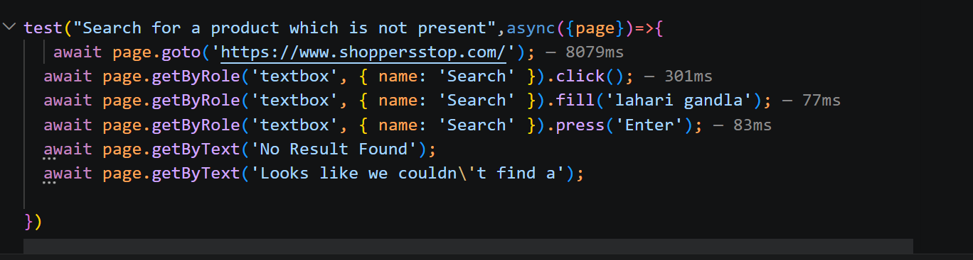

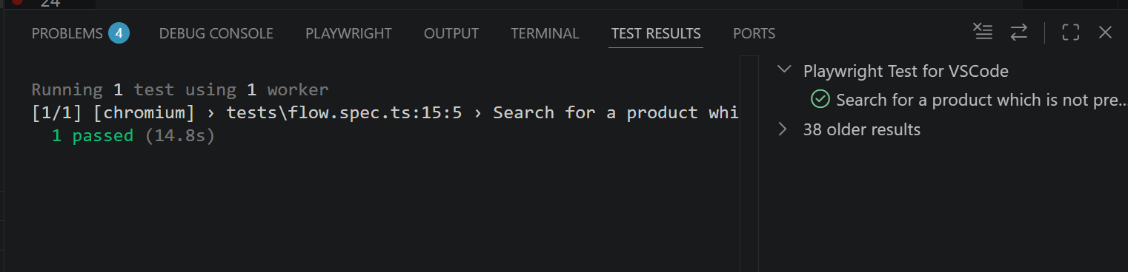

Github link : ust-sdet-training/SDET at lahari_qa_test1Q1

